S.VISHNU VARDHAN REDDY(192312244)
Ex.No.5: MIMO System Simulation with BER Analysis Date

Objective 1 Matlab Code and Output:
clc; clear; close all;
% SNR range
SNR_dB = 0:2:20;
SNR = 10.^(SNR_dB/10);
% MIMO parameters
Nt = 2; Nr = 2;
BER = zeros(1,length(SNR));

for i = 1:length(SNR)
bits = randi([0 1],10000,1);
symbols = 2*bits-1; % BPSK
H = (randn(Nr,Nt) + 1j*randn(Nr,Nt))/sqrt(2);
noise = (randn(Nr,10000) + 1j*randn(Nr,10000))/sqrt(2*SNR(i));
tx = H(1,1)*symbols' + noise(1,:);
rx = real(tx) > 0;
BER(i) = sum(rx' ~= bits)/length(bits);
end
figure
% -------- Graph 1: BER vs SNR --------
subplot(2,1,1)
semilogy(SNR_dB,BER,'-o','LineWidth',2)
title('MIMO BER Performance vs SNR')
xlabel('SNR (dB)')
ylabel('Bit Error Rate (BER)')
grid on
% -------- Graph 2: SNR vs Quality Indicator --------
subplot(2,1,2)
plot(SNR_dB,1-BER,'-s','LineWidth',2)
title('MIMO System Reliability vs SNR')
xlabel('SNR (dB)')
ylabel('Reliability (1 - BER)')
grid on
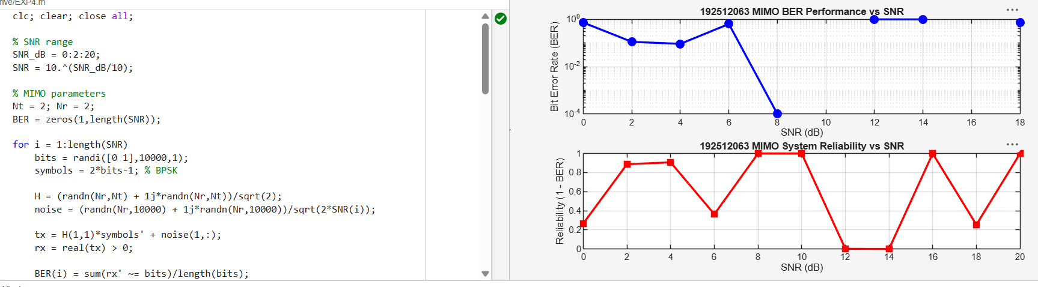
Objective 2 Matlab Code and Output:
clc; clear; close all;
% SNR range (dB)
SNR_dB = 0:2:20;
SNR = 10.^(SNR_dB/10);
% MIMO parameters
Nt = 2; Nr = 2;
% Simulated reliability metric (inverse BER model)
Reliability = zeros(1,length(SNR));
for i = 1:length(SNR)
% simple channel model effect
H = (randn(Nr,Nt) + 1j*randn(Nr,Nt))/sqrt(2);
noise_power = 1/SNR(i);
% reliability increases with SNR
Reliability(i) = 1 - exp(-SNR(i)/10);
end
figure
% -------- Graph 1: SNR vs Reliability --------
subplot(2,1,1)
plot(SNR_dB, Reliability, '-o', 'LineWidth', 2)
title('MIMO Reliability vs SNR')
xlabel('SNR (dB)')
ylabel('Reliability (0 to 1)')
grid on
% -------- Graph 2: SNR vs Noise Effect --------
subplot(2,1,2)
plot(SNR_dB, noise_power*ones(size(SNR_dB)), '-s', 'LineWidth', 2)
title('Noise Power Variation with SNR')
xlabel('SNR (dB)')
ylabel('Noise Power')
grid on 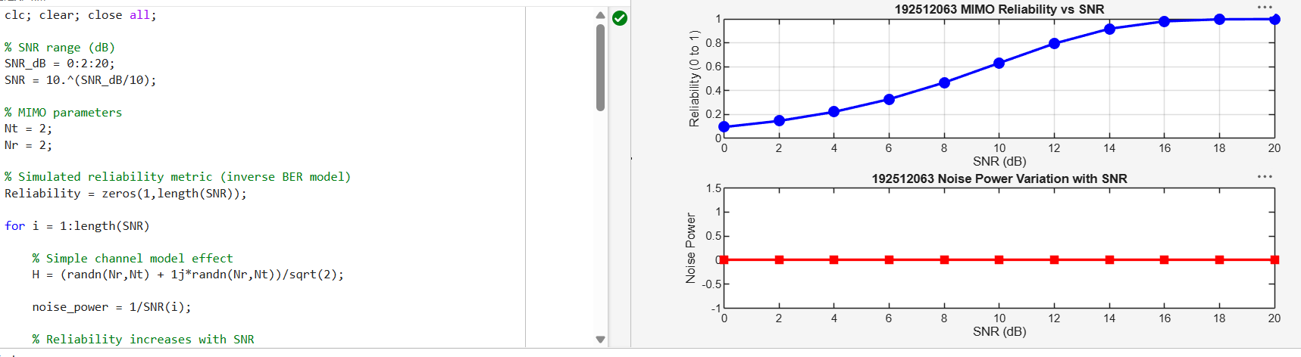

FIG.2.

Objective 3 Matlab Code and Output:
clc; clear; close all;
% Resource Block parameters
rb_bw = 180e3; % 180 kHz per RB
% Users
users = 1:5;
% Allocated Resource Blocks per user
alloc_RB = [10 12 8 15 5];
% Modulation efficiency (bits/symbol)
mod_eff = [2 4 6 4 2]; % QPSK, 16QAM, 64QAM etc.
% Throughput calculation (Mbps)
throughput = (alloc_RB .* rb_bw .* mod_eff) / 1e6;

% Display results
disp('User Throughput (Mbps):')
disp(throughput')
figure
% -------- Graph 1: Throughput per User --------
subplot(2,1,1)
plot(users, throughput, '-o','LineWidth',2)
title('OFDMA User Throughput')
xlabel('User Index')
ylabel('Throughput (Mbps)')
grid on
% -------- Graph 2: RB vs Throughput --------
subplot(2,1,2)
plot(alloc_RB, throughput, '-s','LineWidth',2)
title('Resource Blocks vs Throughput')
xlabel('Allocated Resource Blocks')
ylabel('Throughput (Mbps)')
grid on
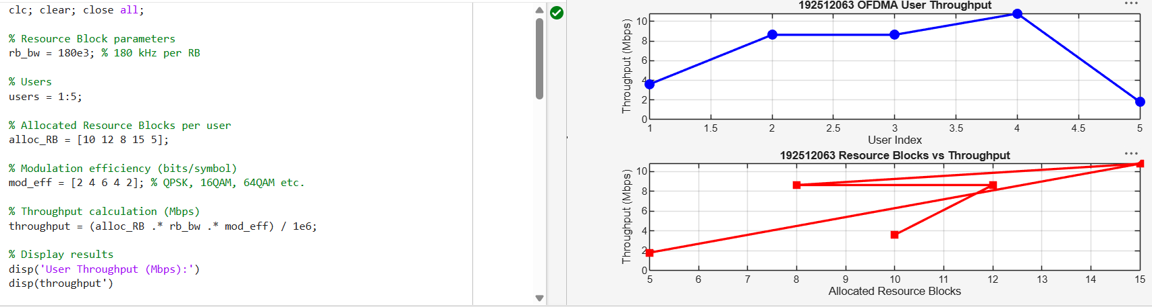

FIG.3.

